Question 1:

(a)
Legend:
IF = instruction Fetch
ID = Instruction Decode
E = Execute
M = Memory Access
WB = Write Back
? = No useful Work
Arrows = forwarding
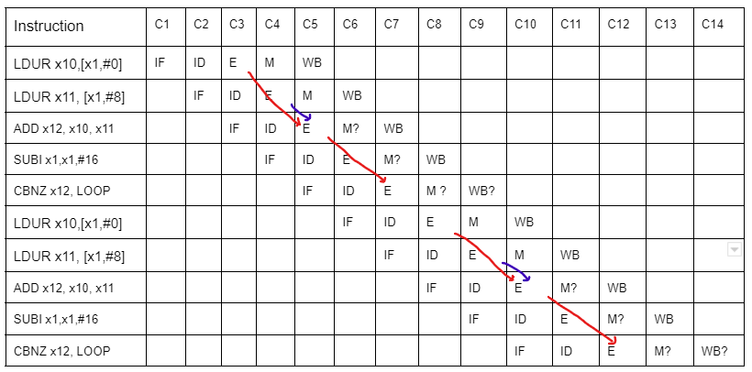

(b)
”Begin with the cycle during which the SUBI is in the IF stage and end with the cycle during which the CBNZ is in the IF stage”
When SUBI is in stage IF, then it starts with C4 and the end cycle during which CBNZ is in IF stage is when it is either C5 or C10.
If it ends on C5:
Ans: 1 stage , C5
If it ends on C10:
Ans: 2 stage , C5 and C10

Question 2:

(a)

If CPI is 2, then we access 0.5 instruction per cycle.
To access an instruction we have a cache miss of 0.3% which is 0.003.
So to access an instruction : Instr/cycle * cache miss * block size = 0.5*0.003*64
Instruction access = 0.096 bytes/cycle
Read Request = 250/1000 = 0.25.
Read miss request = inst/cycle * read request * cache miss * block size
= 0.5 * 0.25 * 0.02 * 64 = 0.16
Write request = 100/1000 = 0.1
I’m assuming , 1 word = 4 bytes.
Write = instruction per cycle * write request * 1 word(byte)
= 0.5 * 0.1 * 4 = 0.2 bytes/cycle
Write-through cache also miss, as it reads from RAM
Write misses(reading from RAM) = instruction/cycle * write request * cache miss * block size
= 0.5 * 0.1 * 0.02 * 64 = 0.064 bytes/cycle
Ans:
Read bandwidth = Instruction access + read miss + write miss
= 0.096 + 0.16 + 0.064
= 0.32 bytes/cycle
Write bandwidth = Write
= 0.2 bytes/cycle
(b)

Any line could have dirty data. Read request can also cause eviction

Read requirement = instr/cycle * read request * cache miss * dirtyData * block size
= 0.5 * 0.25 * 0.03 * 0.3 * 64 = 0.072 bytes/cycle
Write requirement (does read and write too)
=inst/cycle * (read + write req) * cache miss * dirtyData * block size
= 0.5 * (0.25+0.1) * 0.02 * 0.3 * 64 = 0.0672 bytes/cycle

(c)
(i)
Double data cache miss rate = 4% = 0.04
Using same steps as in (a)
Instruction access = 0.096 bytes/cycle
Read miss request = = inst/cycle * read request * cache miss * block size
= 0.5 * 0.25 * 0.04 * 64 = 0.32
Write misses(reading from RAM) = instruction/cycle * write request * cache miss * block size
= 0.5 * 0.1 * 0.04 * 64 = 0.128 bytes/cycle

Read bandwidth = Instruction access + read miss + write miss
= 0.096 + 0.32 + 0.128
= 0.544 bytes/cycle
Write = instruction per cycle * write request * 1 word(byte)
= 0.5 * 0.1 * 4 = 0.2 bytes/cycle

A difference of 0.224 bytes/cycle more when increasing data cache miss rate and write request stay the same

(ii)
Reduce Instruction Count rate by half = CPI = 1
So to access an instruction : Instr/cycle * cache miss * block size = 1 *0.003*64
Instruction access = 0.192 bytes/cycle

Read miss request = inst/cycle * read request * cache miss * block size
= 1 * 0.25 * 0.02 * 64 = 0.32

Write = instruction per cycle * write request * 1 word(byte)
= 1 * 0.1 * 4 = 0.4 bytes/cycle

Write misses(reading from RAM) = instruction/cycle * write request * cache miss * block size
= 1 * 0.1 * 0.02 * 64 =0.128 bytes/cycle

Read bandwidth = Instruction access + read miss + write miss
= 0.192 + 0.32 + 0.128
= 0.64 bytes/cycle
Write bandwidth = 0.4 bytes/cycle

Reducing IC rate , we read more data from 0.32 to 0.64
And we also write twice more data from 0.2 to 0.4

Question 3:
(a)
ADD x5, x2, x1
NOP
NOP
LDUR x3, [x5, #4]
LDUR x2, [x2, #0]
NOP
ORR x3, x5, x3
NOP
NOP
STUR x3, [x5, #0]

(b)
This is the least number of NOPs i.e we cannot reduce the number of NOPs

(c)
We only need hazard detection so that we can stall when an instruction uses the result of load which executed just before (for eg Ldur x3 then orr x3 next instr). But in this case it does not happen thus the code will execute without any problem.

(d)
C1 : ForwardA = X; ForwardB = X(no instr in Execute stage)
C2 : ForwardA = X; ForwardB = X(no instr in Execute stage)
C3 : ForwardA = 0; ForwardB = 0 (no forwarding)
C4 : ForwardA = 2; ForwardB = 0 (base register value taken from previous result)
C5 : ForwardA = 1; ForwardB = 1 (base register taken from 2 instr before)
C6 : ForwardA = 0; ForwardB = 2 (x5 and x3 taken from before)
C7 : ForwardA = 0; ForwardB = 2 (base register from register file taken)

*(e)

(4)
(a)
Word/Address = 64 bits = 8 bytes = 2^3
1 block has 2 words= 2 * 8 = 16 bytes //(2^4) 4 for total offset
Cache = 32 KiB = 2^15 bytes of data
Lines of data = 2^15 / 16 = 2048 bytes = 2^11 //(11-bit index)

An address consists of :
Index (n) = 11 bit
Word offset = 3 bit
2-word block = 2 = 2^1
m = 1
Tag = 64 - (11+4)
= 49
Cache = Cache in bit + tag in bit + Valid bits(1 bit)
= (2^15 * 8) + (2^11 * 49) + (2^11 * 1)
Ans = 364 544 bits

(b)
Word = 64 bits = 8 bytes
1 block = 16 words = (2 ^ 4)
1 block = 8*16 = 128 bytes = 2^7 bytes (7 total offset)
Cache = 64 KiB = 2^16 bytes,
Lines of data = (2^16) / (2^ 7) = 2^9 //(9-bit index)
Address :
Index (n) = 9
16 word block = 2^m = 2^3 : m = 3
Block offset = 4 bit
Tag = 64 - (9 + 7)
= 48

Cache = Cache in bit + tag in bit + Valid bits(1 bit)
= (2^16 * 8) + (2^9 * 48) + (2^9 * 1)
Answer = 549,376 bits

Difference = 549376 - 364544 = 184832
=184832/ 364544 = 50.7% bigger

The amount of data can be increased by only increasing block size as then the performance will stay almost the same.

(c)
It has a larger block size thus it will have more miss penalty and more hit time than the first cache.

*(d)

5 a)
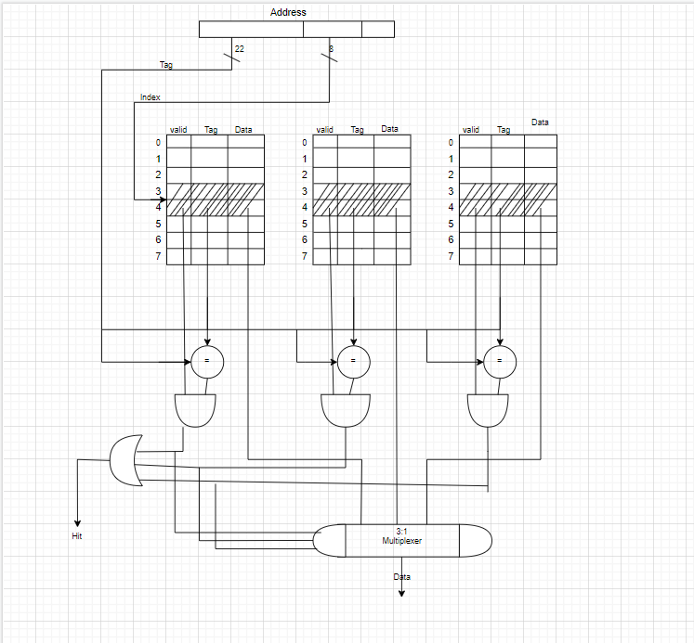

b)
t(x) = tag at index x

Word address | Binary | Tag | Index | offset | Hit/Miss | Set 0 | Set 1 | Set 2
0x03 | 0000 0011 | 0x0 | 1 | 1 | Miss | t(1)=0
0xb4 | 1011 0100 | 0xb | 2 | 0 | Miss | t(1)=0  t(2)=b
0x2b | 0010 1011 | 0x2 | 5 | 1 | Miss | t(1)=0  t(2)=b  t(5)=2
0x02 | 0000 0010 | 0x0 | 1 | 0 | Hit | t(1)=0  t(2)=b  t(5)=2
0xbe | 1011 1110 | 0xb | 7 | 0 | Miss | t(1)=0  t(2)=b  t(5)=2  t(7)=b
0x58 | 0101 1000 | 0x5 | 4 | 0 | Miss | t(1)=0  t(2)=b  t(5)=2  t(7)=b  t(4)=5
0xbf | 1011 1111 | 0xb | 7 | 1 | Hit | t(1)=0  t(2)=b  t(5)=2  t(7)=b  t(4)=5
0x0e | 0000 1110 | 0x0 | 7 | 0 | Miss | t(1)=0  t(2)=b  t(5)=2  t(7)=b  t(4)=5 | t(7) =0
0x1f | 0001 1111 | 0x1 | 7 | 1 | Miss | t(1)=0  t(2)=b  t(5)=2  t(7)=b  t(4)=5 | t(7) =0 | t(7) =1
0xb5 | 1011 0101 | 0xb | 2 | 1 | Hit | t(1)=0  t(2)=b  t(5)=2  t(7)=b  t(4)=5 | t(7) =0 | t(7) =1
0xbf | 1011 1111 | 0xb | 7 | 1 | Hit | t(1)=0  t(2)=b  t(5)=2  t(7)=b  t(4)=5 | t(7) =0 | t(7) =1
0xba | 1011 1010 | 0xb | 5 | 0 | Miss | t(1)=0  t(2)=b  t(5)=2  t(7)=b  t(4)=5 | t(7) =0  t(5)=b | t(7) =1
0x2e | 0010 1110 | 0x2 | 7 | 0 | Miss | t(1)=0  t(2)=b  t(5)=2  t(7)=b  t(4)=5 | t(7) =0  t(5)=b | t(7) =1
0xce | 1100 1110 | 0xc | 7 | 0 | Miss | t(1)=0  t(2)=b  t(5)=2  t(7)=b  t(4)=5 | t(7) =0  t(5)=b | t(7) =c

c)
t(x) = tag at index x

Word address | Binary | Tag | Index | offset | Hit/Miss | Set 0
0x03 | 0000 0011 | 0x0 | 1 | 1 | Miss | t(1)=0
0xb4 | 1011 0100 | 0xb | 2 | 0 | Miss | t(1)=0  t(2)=b
0x2b | 0010 1011 | 0x2 | 5 | 1 | Miss | t(1)=0  t(2)=b  t(5)=2
0x02 | 0000 0010 | 0x0 | 1 | 0 | Hit | t(1)=0  t(2)=b  t(5)=2  t(7)=b
0xbe | 1011 1110 | 0xb | 7 | 0 | Miss | t(1)=0  t(2)=b  t(5)=2  t(7)=b  t(4)=5
0x58 | 0101 1000 | 0x5 | 4 | 0 | Miss | t(1)=0  t(2)=b  t(5)=2  t(7)=b  t(4)=5
0xbf | 1011 1111 | 0xb | 7 | 1 | Hit | t(1)=0  t(2)=b  t(5)=2  t(7)=b  t(4)=5
0x0e | 0000 1110 | 0x0 | 7 | 0 | Miss | t(1)=0  t(2)=b  t(5)=2  t(7)=b  t(4)=5
0x1f | 0001 1111 | 0x1 | 7 | 1 | Miss | t(1)=0  t(2)=b  t(5)=2  t(7)=b  t(4)=5
0xb5 | 1011 0101 | 0xb | 2 | 1 | Hit | t(1)=0  t(2)=b  t(5)=2  t(7)=b  t(4)=5
0xbf | 1011 1111 | 0xb | 7 | 1 | Hit | t(1)=0  t(2)=b  t(5)=2  t(7)=b  t(4)=5
0xba | 1011 1010 | 0xb | 5 | 0 | Miss | t(1)=0  t(2)=b  t(5)=2  t(7)=b  t(4)=5
0x2e | 0010 1110 | 0x2 | 7 | 0 | Miss | t(1)=0  t(2)=b  t(5)=2  t(7)=b  t(4)=5
0xce | 1100 1110 | 0xc | 7 | 0 | Miss | t(1)=0  t(2)=b  t(5)=2  t(7)=b  t(4)=5

(6)
- Assuming the cache is empty at first

Word Address | Binary | Tag | Index | Hit/Miss
0x03 | 0000 0011 | 0x0 | 3 | Miss
0xb4 | 1011 0100 | 0xb | 4 | Miss
0x2b | 0010 1011 | 0x2 | b | Miss
0x02 | 0000 0010 | 0x0 | 2 | Miss
0xbf | 1011 1111 | 0xb | f | Miss
0x58 | 0101 1000 | 0x5 | 8 | Miss
0xbe | 1011 1110 | 0xb | e | Miss
0x0e | 0000 1110 | 0x0 | e | Miss
0xb5 | 1011 0101 | 0xb | 5 | Miss
0x2c | 0010 1100 | 0x2 | c | Miss
0xba | 1011 1010 | 0xb | a | Miss
0xfd | 1111 1101 | 0xf | d | Miss

(b)

Word Address | Binary | Tag | Index | offset | Hit/Miss
0x03 | 0000 001 1 | 0 | 1 | 1 | miss
0xb4 | 1011 010 0 | b | 2 | 0 | miss
0x2b | 0010 101 1 | 2 | 5 | 1 | miss
0x02 | 0000 001 0 | 0 | 1 | 0 | hit
0xbf | 1011 111 1 | b | 7 | 1 | miss
0x58 | 0101 100 0 | 5 | 4 | 0 | miss
0xbe | 1011 111 0 | b | 7 | 0 | hit
0x0e | 0000 111 0 | 0 | 7 | 0 | miss
0xb5 | 1011 010 1 | b | 2 | 1 | hit
0x2c | 0010 110 0 | 2 | 6 | 0 | miss
0xba | 1011 101 0 | b | 5 | 0 | miss
0xfd | 1111 110 1 | f | 6 | 1 | miss

c)

 |  |  | Cache1 | Cache1 | Cache2 | Cache2 | Cache3 | Cache3
Word Address | Binary | Tag | Index | Hit/Miss | Index | Hit/Miss | Index | Hit/Miss
0x03 | 00000 011 | 00000=0x00 | 3 | miss | 1 | miss | 0 | miss
0xb4 | 10110 100 | 10110=0x16 | 4 | miss | 2 | miss | 1 | miss
0x2b | 00101 011 | 00101=0x05 | 3 | miss | 1 | miss | 0 | miss
0x02 | 00000 010 | 00000=0x00 | 2 | miss | 1 | miss | 0 | miss
0xbf | 10111 111 | 10111=0x17 | 7 | miss | 3 | miss | 1 | miss
0x58 | 01011 000 | 01011=0x0b | 0 | miss | 0 | miss | 0 | miss
0xbe | 10111 110 | 10111=0x17 | 6 | miss | 3 | hit | 1 | hit
0x0e | 00001 110 | 00001=0x01 | 6 | miss | 3 | miss | 1 | miss
0xb5 | 10110 101 | 10110=0x16 | 5 | miss | 2 | hit | 1 | miss
0x2c | 00101 100 | 00101=0x05 | 4 | miss | 2 | miss | 1 | miss
0xba | 10111 010 | 10111=0x17 | 2 | miss | 1 | miss | 0 | miss
0xfd | 11111 101 | 11111=0x1f | 5 | miss | 2 | miss | 1 | miss

Cache 1 miss rate = 12/12 * 100 = 100%
Cache 2 miss rate = 10/12 * 100 = 83%
Cache 3 miss rate = 11/12 * 100 = 92%

Cache 2 provides less miss rate thus a better performance

7)
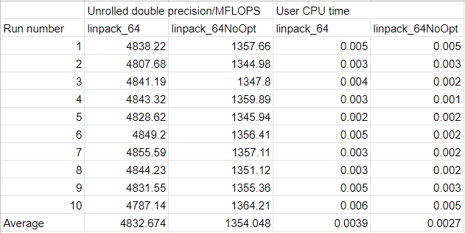
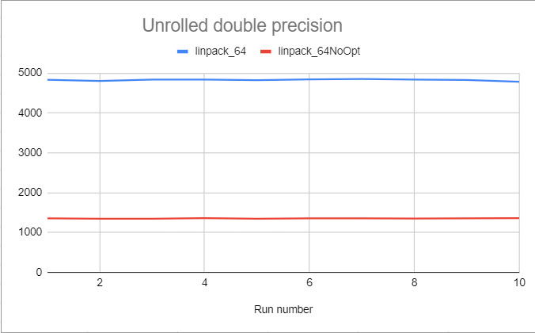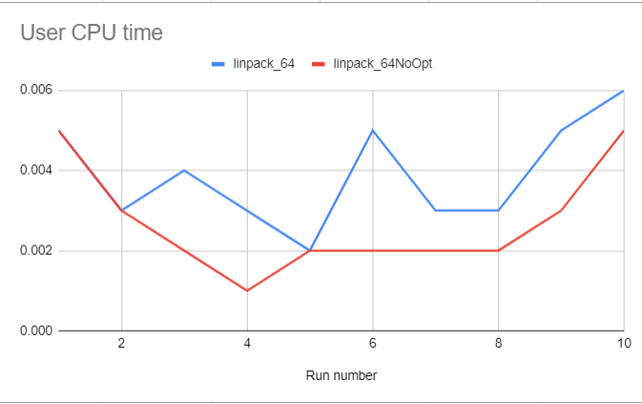

On average both have almost the same cpu time.
But Optimized linpack has a bigger MFLOPS than linpack with no optimize for the double precision.

Unrolling (loop unrolling) is a compiler optimization done to some kind of loop so that it can lower the amount of frequency of branches and loop maintenance instructions

Uptime = load average: 0.68, 0.62, 0.33

